

Semester One Examination, 2020

Question/Answer booklet

MATHEMATICS

SOLUTIONS
SPECIALIST
UNIT 1

Section Two:

Calculator-assumed

WA student number: In figures

In words

Your name

Number of additional
answer booklets used
(if applicable):

Time allowed for this section
Reading time before commencing work: ten minutes
Working time: one hundred minutes

Materials required/recommended for this section
To be provided by the supervisor
This Question/Answer booklet
Formula sheet (retained from Section One)

To be provided by the candidate
Standard items: pens (blue/black preferred), pencils (including coloured), sharpener,
correction fluid/tape, eraser, ruler, highlighters

Special items: drawing instruments, templates, notes on two unfolded sheets of A4 paper, and up to three calculators approved for use in this examination

Important note to candidates
No other items may be taken into the examination room. It is your responsibility to ensure that you do not have any unauthorised material. If you have any unauthorised material with you, hand it to the supervisor before reading any further.

Structure of this paper

Section | Number of  questions  available | Number of  questions to  be answered | Working  time  (minutes) | Marks  available | Percentage  of  examination
Section One:  Calculator-free | 8 | 8 | 50 | 52 | 35
Section Two:  Calculator-assumed | 13 | 13 | 100 | 98 | 65
 |  |  |  | Total | 100

Instructions to candidates

1. The rules for the conduct of examinations are detailed in the school handbook. Sitting this examination implies that you agree to abide by these rules.

2. Write your answers in this Question/Answer booklet preferably using a blue/black pen.
Do not use erasable or gel pens.

3. You must be careful to confine your answers to the specific question asked and to follow any instructions that are specific to a particular question.

4. Show all your working clearly. Your working should be in sufficient detail to allow your answers to be checked readily and for marks to be awarded for reasoning. Incorrect answers given without supporting reasoning cannot be allocated any marks. For any question or part question worth more than two marks, valid working or justification is required to receive full marks. If you repeat any question, ensure that you cancel the answer you do not wish to have marked.

5. It is recommended that you do not use pencil, except in diagrams.

6. Supplementary pages for planning/continuing your answers to questions are provided at the end of this Question/Answer booklet. If you use these pages to continue an answer, indicate at the original answer where the answer is continued, i.e. give the page number.

7. The Formula sheet is not to be handed in with your Question/Answer booklet.
Section Two: Calculator-assumed 65% (98 Marks)
This section has thirteen questions. Answer all questions. Write your answers in the spaces provided.

Working time: 100 minutes.

Question 9 (6 marks)
Determine the size of the angles marked $a, b, c, d, e$ and $f$ shown in the circles below. Where marked, $O$ is the centre of the circle.

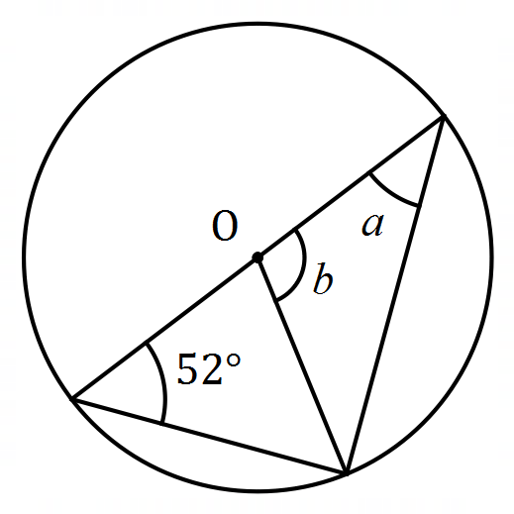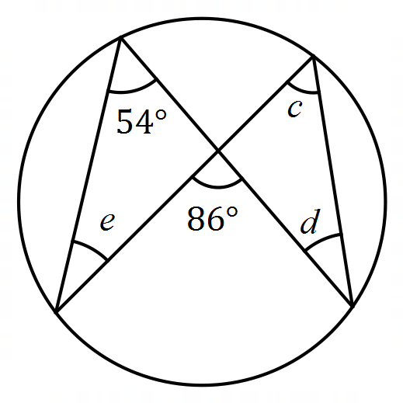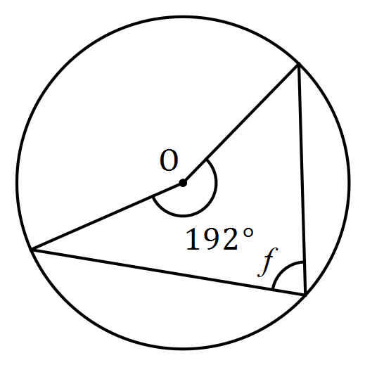
Solution
$$a=90°-52°=38°$$

$$b=2×52°=104°$$

$$c=54°$$

$$d=86°-54°=32°$$

$$e=32°$$

$$f=\frac{1}{2}\left(360°-192°\right)=84°$$

Specific behaviours
each correct angle

Question 10 (5 marks)
Three forces act on an object so that it remains in equilibrium. Two of the forces have magnitudes of $80$ N and $110$ N and the angle between their directions is $105°$. Determine the magnitude of the third force and the angle its direction makes with the smaller force.
Solution
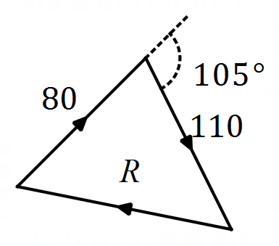

$$R^{2}={80}^{2}+{110}^{2}-2\left(80\right)\left(110\right)\cos{75°} \\ R=118.1 \text{N}$$

$$\frac{\sin{θ}}{110}=\frac{\sin{75°}}{118.1} \\ θ=64.1°$$

Hence angle between directions is $180-64=116°$.

Specific behaviours
diagram showing vector sum is zero
✓ uses cosine rule to solve triangle
✓ magnitude of resultant
✓ uses sine rule
✓ direction with smaller force

Question 11 (8 marks)
(a) An art gallery plans to display a single painting on each of the three walls in a room. Determine how many arrangements of paintings are possible in the room if they have a selection of $24$ different paintings to choose from. (2 marks)
Solution
$$^{24}P_{3}=24×23×22=12 144$$

Specific behaviours
indicates method
✓ correct number of arrangements

(b) In another room, the gallery plan to hang $8$ different paintings in a row. If $2$ of the paintings are by the artist Marr, determine the number of different arrangements of paintings that are possible when

(i) the paintings by Marr must be at the ends. (2 marks)
Solution
$$2×6!=1 440$$

Specific behaviours
uses $6!$
✓ correct number of arrangements

(ii) the paintings by Marr must be next to each other. (2 marks)
Solution
$$2!×7!=10 080$$

Specific behaviours
groups Marr together
✓ correct number of arrangements

(iii) the paintings by Marr must be apart and not at the ends. (2 marks)
Solution
$6$ non-Marr leave $5$ spaces to hang Marr in between (N_N_N_N_N_N):

$$n=6!×5×4=14 400$$

Specific behaviours
indicates method
✓ correct number of arrangements

Question 12 (8 marks)
(a) Prove that chords of equal length subtend equal angles at the centre of a circle.
(3 marks)
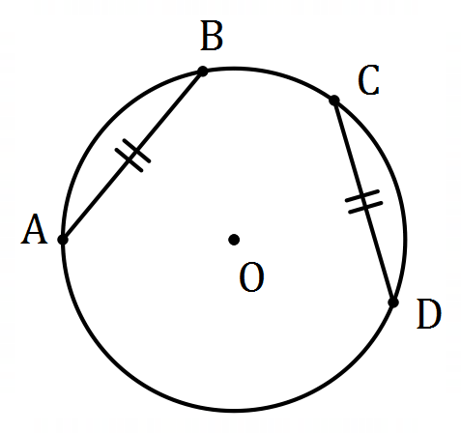
Solution
$AB=DC$ (given)
$OA=OB=OC=OD=r$ (all radii)

Hence $ΔOAB≡ΔOCD$ (SSS)

Hence $∠AOB=∠COD$ - chords of equal length subtend equal angles at the centre.

Specific behaviours
establishes congruency of sides
✓ establishes congruency of triangles
✓ concludes equal angles

(b) Points $P$ and $Q$ lie on a circle of radius $23.3$ cm so that $PQ=21$ cm. Determine

(i) the distance of chord $PQ$ from the centre of the circle. (3 marks)
Solution
Let midpoint of chord be $M$. Then
$$OM^{2}=r^{2}-PM^{2} \\ OM=\sqrt{{23.3}^{2}-{10.5}^{2}} \\ =20.8 \text{cm}$$

Specific behaviours
✓ uses/defines midpoint or sketch diagram
indicates correct method
✓ correct distance

(ii) the angle subtended by chord $PQ$ at the centre of the circle. (2 marks)
Solution
Let $θ=∠POM$ (half angle required). Then
$$θ=\sin^{-1}\left(\frac{10.5}{23.3}\right) \\ =26.78° \\ ∠POQ=2θ \\ ≈53.6°$$

Specific behaviours
indicates correct method
✓ correct angle

Question 13 (7 marks)
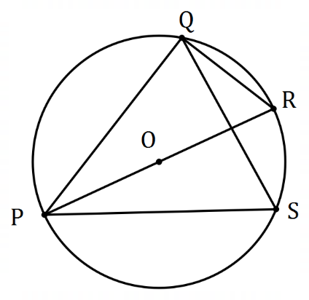
(a) The diagram shows points $P, Q, R$ and $S$ that
lie on the circumference of a circle centre $O$.
$PR$ is a diameter and the size of $∠QPR=27°$.

Determine, with reasons, the size of $∠PSQ$. (3 marks)

Solution
$∠PQR=90°$ (angle in semicircle)
$∠PRQ=180°-90°-27°=63°$ (angle sum in triangle)
$∠PSQ=∠PRQ=63°$ (angles on same arc)

Specific behaviours
uses angle in semicircle
✓ uses angle sum in triangle
✓ correct size of angle, with reason

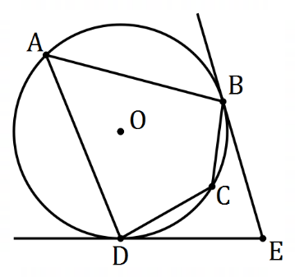

(b) In the diagram shown, $A, B, C$ and $D$ are points
on the circumference of a circle with centre $O$.
Tangents to the circle at $B$ and $D$ intersect at $E$.

Determine, with justification, the size of $∠BCD$
when $∠BED=72°$. (4 marks)
Solution
$∠OBE=∠ODE=90°$ (radius-tangent angle)
$∠BOD=360°-180°-72°=108°$ (angle sum of quadrilateral $BODE$)
$∠BAD=\frac{1}{2}\left(108°\right)=54°$ (centre-circumference angles)
$∠BCD=180°-54°=126°$ (opposite angles in cyclic quadrilateral)

Specific behaviours
uses radius-tangent angle
✓ correct $∠BOD$
✓ uses angle at centre-circumference
✓ correct angle

Question 14 (8 marks)
In quadrilateral $OPQR$ shown below, $M$ lies on $QR$ so that $\left|\vec{QM}\right|=3|\vec{MR}|$.

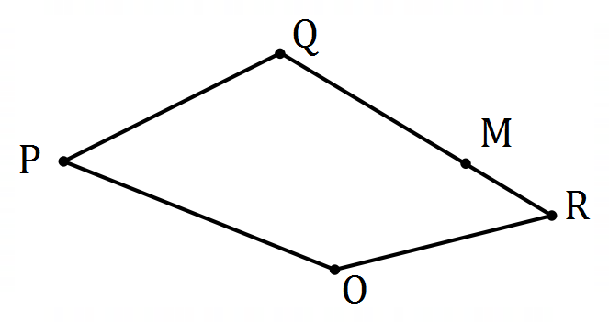
(a) If $\vec{OP}=p, \vec{OQ}=q$ and $\vec{OR}=r$, express the following in terms of $p, q$ and/or $r$.
Solution
$$\vec{PR}=r-p$$

Specific behaviours
correct expression

(i) $\vec{PR}$. (1 mark)

Solution
$$\vec{RM}=\frac{1}{4}\vec{RQ}=\frac{1}{4}(q-r)$$

Specific behaviours
uses correct vector notation
✓ correct expression

(ii) $\vec{RM}$. (2 marks)

(iii) $\vec{PM}$. (2 marks)
Solution
$$\vec{PM}=\vec{PR}+\vec{RM} \\ =r-p+\frac{1}{4}(q-r) \\ =\frac{3}{4}r+\frac{1}{4}q-p$$

Specific behaviours
indicates suitable vector sum
✓ correct expression

(b) If $O$ is the origin and points $P, Q$ and $R$ have coordinates $\left(-2, 39\right), (28, -14)$ and $(32, -18)$ respectively, determine the distance $PM$. (3 marks)
Solution
$$\vec{PM}=\frac{3}{4}\left(\begin{matrix}32 \\ -18\end{matrix}\right)+\frac{1}{4}\left(\begin{matrix}28 \\ -14\end{matrix}\right)-\left(\begin{matrix}-2 \\ 39\end{matrix}\right) \\ =\left(\begin{matrix}33 \\ -56\end{matrix}\right)$$
$$\left|\left(\begin{matrix}33 \\ -56\end{matrix}\right)\right|=65$$

Specific behaviours
substitutes into expression for $\vec{PM}$
✓ $\vec{PM}$
✓ correct magnitude

Question 15 (8 marks)
(a) The vertices of quadrilateral $ABCD$ lie on the circumference of a circle centre $O$ shown below. Given that $∠ADC=95°$ and $∠AOB=84°$, determine with reasoning the size of angle $BCO$. (4 marks)

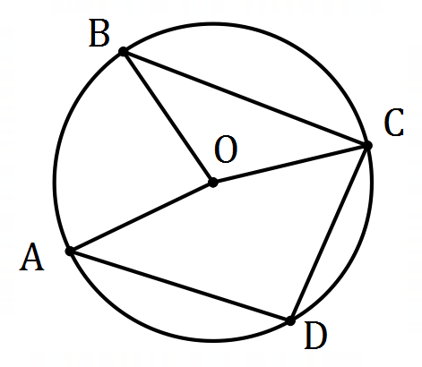
Solution
$∠AOC=2×∠ADC=190°$ (angles at centre-circumference)

$∠BOC=∠AOC-∠AOB=190°-84°=106°$ (adjacent angles)

$∠BCO=\frac{1}{2}\left(180°-∠BOC\right)$ (isosceles triangle)
$$∠BCO=\frac{1}{2}\left(180°-106°\right)=37°$$

Specific behaviours
uses angles at centre-circumference
✓ uses adjacent angles
✓ uses isosceles triangles
✓ correct angle

(b) The vertices of triangle $ABC$ lie on the circumference of a circle. Given that $AB=10$ cm, $AC=7$ cm and $BC=6$ cm, prove by contradiction that $AB$ is not a diameter of the circle.
(4 marks)
Solution
Assume that $AB$ is a diameter of the circle, so that the angle in a semicircle theorem implies that $ΔABC$ must be right angled at $C$.

If $ΔABC$ is right angled, then Pythagoras' theorem implies that $AC^{2}+BC^{2}=AB^{2}$.

But $AC^{2}+BC^{2}=7^{2}+6^{2}=49+36=85$ and $AB^{2}={10}^{2}=100$.

This result contradicts our assumption that $AB$ is a diameter and so $AB$ cannot be a diameter of the circle.

Specific behaviours
states assumption and uses angle in semicircle theorem
✓ uses Pythagoras' theorem to state relationship between side lengths
✓ shows relationship is false
✓ explains contradiction

Question 16 (7 marks)
(a) A calculator can generate random integers between $10$ and $25$. Use the pigeonhole principle to explain why $49$ random integers should be generated to be certain that at least $4$ of them are the same. (3 marks)

Solution
There are $16$ pigeonholes (integers from $10$ to $25$) and each random integer produced is a pigeon.

By the pigeonhole principle:
If only $48$ integers are produced, there will be at least $\left\lceil 48÷16\right\rceil =3$ pigeons in at least one pigeonhole, but if $49$ integers are produced then there will be at least $\left\lceil 49÷16\right\rceil =4$ pigeons in at least one pigeonhole.

Hence $49$ integers should be produced to be certain that at least $4$ of them are the same.

Specific behaviours
defines pigeonholes
✓ shows $48$ insufficient
✓ shows $49$ sufficient

(b) $16$ customers bought a total of $130$ items from a supermarket. Given that each customer bought at least one item, show that at least two of the customers bought the same number of items. (4 marks)
Solution
Assume that each customer bought a different number of items.

Then the minimum number of items bought would be:

$$1+2+3+…+15+16=136$$

But the number of items bought ($130$) was less than this minimum, which contradicts the assumption made.

Hence at least two customers bought the same number of items.

Specific behaviours
states assumption
✓ uses assumption to calculate minimum
✓ states contradiction
✓ summary statement

Question 17 (9 marks)
(a) A body is moving at $18$ m/s on a bearing of $150°$. Determine the equivalent velocity vector in exact form $ai+bj$. (2 marks)
Solution
$$18\left(\begin{matrix}cos⁡(-60) \\ sin⁡(-60)\end{matrix}\right)=9i-9\sqrt{3}j \text{m/s}$$

NB Might choose to use CAS
Specific behaviours
indicates correct method
✓ correct vector using exact values

(b) Determine the bearing and speed of a body moving with velocity $-1.9i+18j$ m/s.
(2 marks)
Solution
Speed: $\sqrt{{\left(-1.9\right)}^{2}+{18}^{2}}=18.1$ m/s

Bearing: $360-\tan^{-1}\left(\frac{1.9}{18}\right)=360-6=354°$

NB Might choose to use CAS
Specific behaviours
correct speed
✓ correct bearing

(c) The velocity vectors of particles $P, Q$ and $R$ are $\left(\begin{matrix}x \\ -11\end{matrix}\right), \left(\begin{matrix}9 \\ y\end{matrix}\right)$ and $\left(\begin{matrix}1.8 \\ -1.4\end{matrix}\right)$ m/s respectively.
If particles $P$ and $Q$ have the same speed and particles $Q$ and $R$ are moving in the same direction, determine the values of $x$ and $y$. (5 marks)
Solution
$$\left(\begin{matrix}9 \\ y\end{matrix}\right)=k\left(\begin{matrix}1.8 \\ -1.4\end{matrix}\right)⇒k=5$$

$$y=5×-1.4=-7$$

$$\left|\left(\begin{matrix}x \\ -11\end{matrix}\right)\right|=\left|\left(\begin{matrix}9 \\ -7\end{matrix}\right)\right|$$
$$x^{2}+121=81+49 \\ x^{2}-9=0$$
$$x=±3$$

Specific behaviours
uses parallel vectors to obtain $k$
✓ value of $y$
✓ equates magnitudes
✓ expands and simplifies
✓ both values for $x$

Question 18 (8 marks)
A school yearbook is produced by a committee of $3$ teachers and $8$ students. $5$ teachers and $17$ students have nominated for the committee.

(a) Determine how many different committees could be formed from the nominations.
(2 marks)
Solution
$$\left(\begin{matrix}5 \\ 3\end{matrix}\right)\left(\begin{matrix}17 \\ 8\end{matrix}\right)=10×24310=243 100$$

Specific behaviours
chooses teachers and students separately
✓ correct number

(b) The student nominations include two sets of twins. Determine how many different committees could be chosen that include at least one set of twins. (4 marks)
Solution
Choose students with at least one set of twins (Set A, Set B, Others):

$$n=\left(\begin{matrix}2 \\ 2\end{matrix}\right)\left(\begin{matrix}2 \\ 2\end{matrix}\right)\left(\begin{matrix}13 \\ 4\end{matrix}\right)+\left[\left(\begin{matrix}2 \\ 2\end{matrix}\right)\left(\begin{matrix}2 \\ 1\end{matrix}\right)+\left(\begin{matrix}2 \\ 1\end{matrix}\right)\left(\begin{matrix}2 \\ 2\end{matrix}\right)\right]\left(\begin{matrix}13 \\ 5\end{matrix}\right)+\left[\left(\begin{matrix}2 \\ 2\end{matrix}\right)\left(\begin{matrix}2 \\ 0\end{matrix}\right)+\left(\begin{matrix}2 \\ 0\end{matrix}\right)\left(\begin{matrix}2 \\ 2\end{matrix}\right)\right]\left(\begin{matrix}13 \\ 6\end{matrix}\right) \\ =715+5148+3432 \\ =9295$$
Ways to choose whole committee: $\left(\begin{matrix}5 \\ 3\end{matrix}\right)×9295=92 950$

Specific behaviours
indicates isolation of cases
✓ uses systematic approach
✓ correct ways to choose students
✓ correct number of committees

(c) Suppose one of the teachers in the committee will be appointed as treasurer and one of the students will be appointed as secretary. Determine how many different committees can be formed with this structure. (2 marks)
Solution
Select a teacher and others, select a student and others:

$$\left(\begin{matrix}5 \\ 1\end{matrix}\right)\left(\begin{matrix}4 \\ 2\end{matrix}\right)×\left(\begin{matrix}17 \\ 1\end{matrix}\right)\left(\begin{matrix}16 \\ 7\end{matrix}\right)=30×194480 \\ =5 834 400$$

Specific behaviours
indicates correct method
✓ correct number

Question 19 (8 marks)
Oil platform T lies $66.5$ km away from another oil platform F on a bearing of $215°$. A steady current of $4.5$ km per hour flows between the platforms on a bearing of $100°$. A small boat at F, with a cruising speed of $12$ km per hour, needs to arrive at T by $4$ pm.

Determine the bearing that the boat should steer and the latest time it should depart from F.
Solution
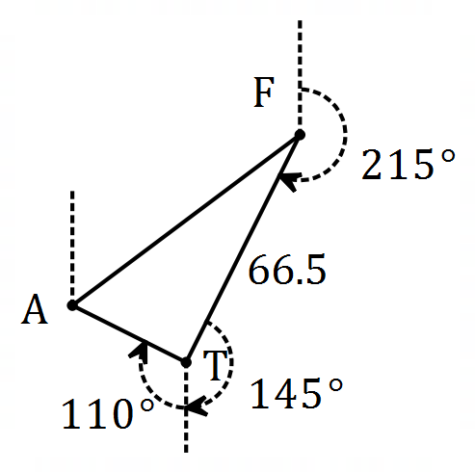

$$∠T=360°-110°-145°=105°$$

If journey takes $t$ hours, then $AF=12t$ and $AT=4.5t$.

$∠F$ using sine rule:
$$\frac{\sin{F}}{4.5t}=\frac{\sin{105°}}{12t}⇒\sin{F}=\frac{4.5\sin{105°}}{12}$$

Hence $∠F=21.24°$ and $∠A=180°-20.24°-105°=53.76°$.

Bearing to steer: $215°+21.24°≈236°$

Distance $AF$ using sine rule:
$$\frac{AF}{\sin{105°}}=\frac{66.5}{\sin{53.76°}}⇒AF=79.64$$

$$t=79.64÷12=6.636 \text{h}=6 \text{h} 38 \text{m}$$

Hence steer on bearing $236°$ and leave before $09:22 \text{am}$.

Specific behaviours
sketch diagram
✓ angle at T
✓ equation using sine rule
✓ solves angles in triangle
✓ solves for second side in triangle
✓ journey time in hours
✓ correct time to leave
✓ correct bearing

Question 20 (8 marks)
Circles $C_{1}$ and $C_{2}$ intersect at points $P$ and $Q$. $C_{1}$ passes through $O$, the centre of $C_{2}$. $R$ lies on $C_{2}$ so that line segment $RS$ is tangential to $C_{1}$ at $Q$. Let $∠PRQ=α$.

(a) Sketch a diagram to show the above information. (3 marks)
Solution
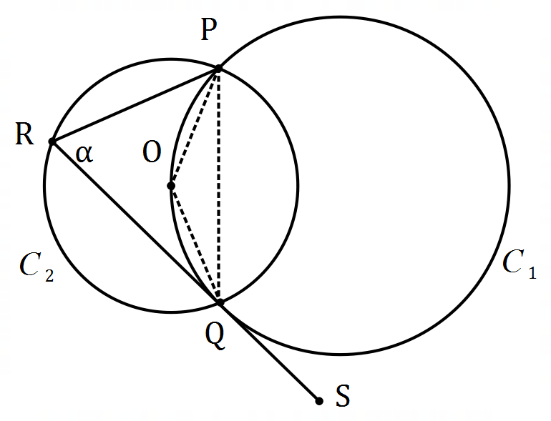
Specific behaviours
$C_{1}$ passing through centre of $C_{2}$
✓ tangent $PQS$
✓ marks angle

(b) Determine $∠POQ$ in terms of $α$. (1 mark)
Solution
$∠POQ=2α$ (angle centre-circumference $C_{2}$)

Specific behaviours
correct expression

(c) Explain why $∠PQS=2α$. (1 mark)
Solution
$∠PQS=∠POQ$ (alternate angles $C_{1}$)

Specific behaviours
states equal to $∠POQ$ using circle theorem

(d) Prove that $PQ=QR$. (3 marks)
Solution
$∠RPQ=2α-α=α$ (exterior - interior sum in $ΔRPQ$)

$∠RPQ=α=∠PRQ⇒ΔRPQ$ is isosceles

Hence $PQ=QR$.

Specific behaviours
deduces $∠RPQ$ with reason
✓ states $ΔRPQ$ isosceles
✓ deduces lengths equal

Question 21 (8 marks)
Particle $A$, initially at the point with position vector $42i-25j$ cm, moves with a constant velocity of $-8i+15j$ cm/s. Particle $B$ is stationary at the point with position vector $-35i+11j$.

(a) Determine the initial distance of $A$ from $B$. (2 marks)
Solution
$$\vec{AB}=\left(\begin{matrix}-35 \\ 11\end{matrix}\right)-\left(\begin{matrix}42 \\ -25\end{matrix}\right)=\left(\begin{matrix}-77 \\ 36\end{matrix}\right)$$

$$|\vec{AB}|=85 \text{cm}$$

Specific behaviours
vector $\vec{AB}$
✓ correct distance

(b) Determine an expression for the distance $d$ between $A$ and $B$ after $t$ seconds. (3 marks)
Solution
$$\vec{AB}=\left(\begin{matrix}-35 \\ 11\end{matrix}\right)-\left[\left(\begin{matrix}42 \\ -25\end{matrix}\right)+t\left(\begin{matrix}-8 \\ 15\end{matrix}\right)\right] \\ =\left(\begin{matrix}8t-77 \\ 36-15t\end{matrix}\right)$$

$$d=\sqrt{{\left(8t-77\right)}^{2}+{\left(36-15t\right)}^{2}} \\ =17\sqrt{t^{2}-8t+25}$$

Specific behaviours
position vector for $A$ at time $t$
vector $\vec{AB}$
✓ distance expression (no need to simplify)

(c) Sketch a graph of $d$ against $t$ and hence determine the time that minimises $d$ and state what this minimum distance is. (3 marks)

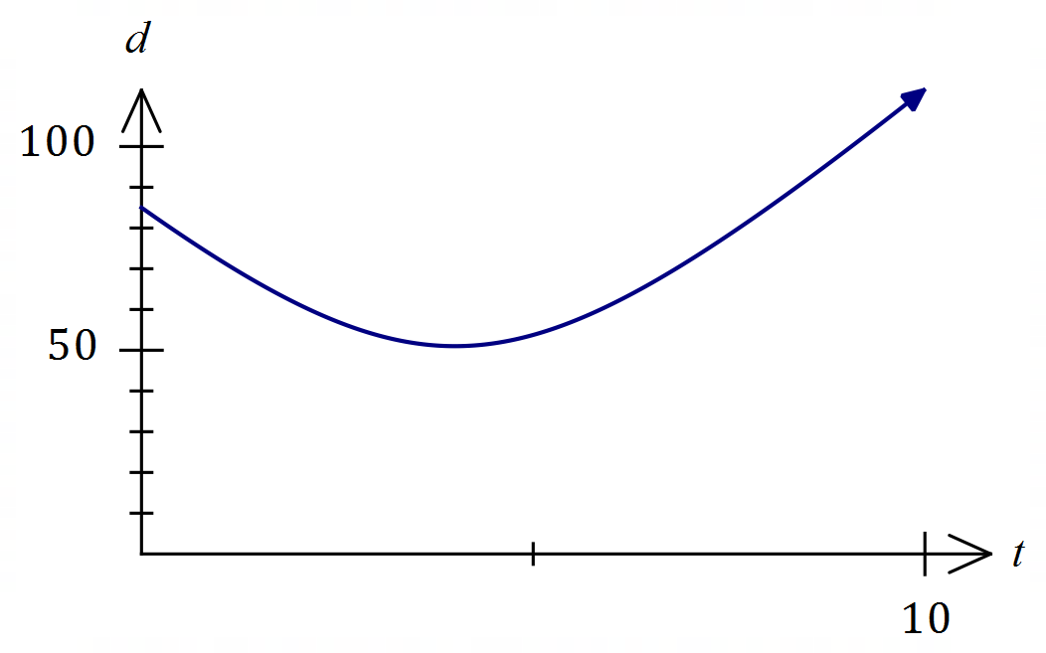
Solution
Minimum when $t=4$ s

Minimum distance is $51$ cm

Specific behaviours
sketch graph
✓ time
✓ minimum distance

Supplementary page

Question number: _________

Supplementary page

Question number: _________

Supplementary page

Question number: _________

Supplementary page

Question number: _________

© 2020 WA Exam Papers. Baldivis Secondary College has a non-exclusive licence to copy and communicate this document for non-commercial, educational use within the school. No other copying, communication or use is permitted without the express written permission of WA Exam Papers. SN261-151-8.

